8.94: The trick here is to notice that the final configuration is the same as if the canoe assumed symmetricalhas been rotated about its center of mass. Intially, the center of mass is a distance 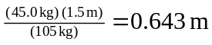 from the center of the canoe, so in rotating about this point the center of the canoe would move 